**Running Web Socket Using Tomcat From Eclipse**

After build the project as war

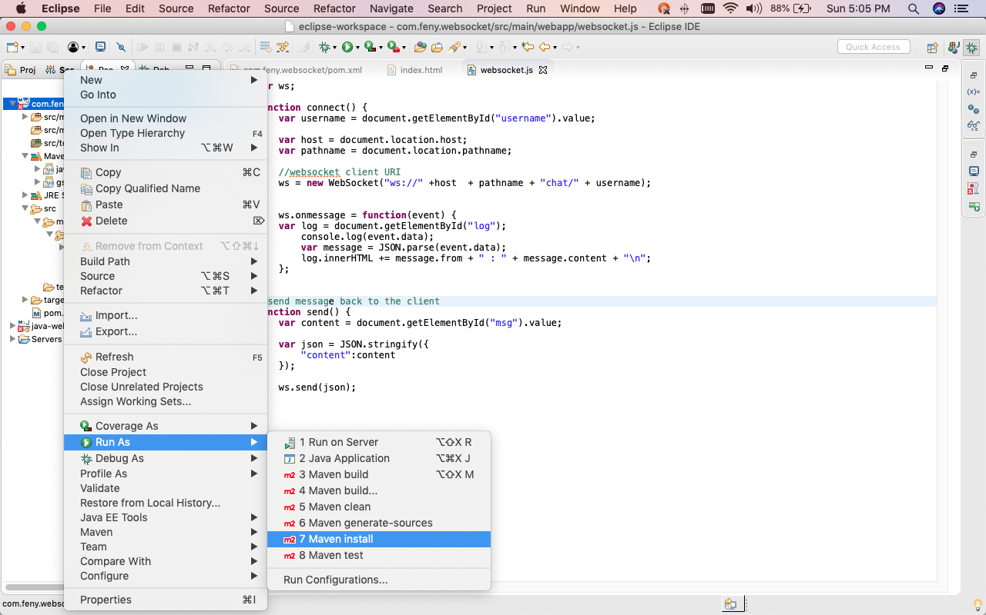

The port number will be the same as the one used for connections via the **http** protocol, e.g. **8080**.

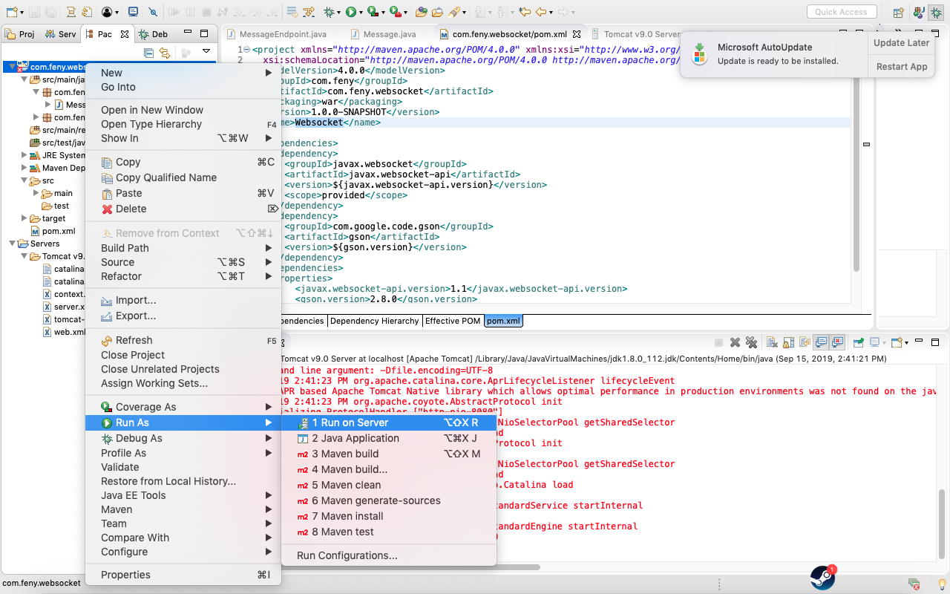

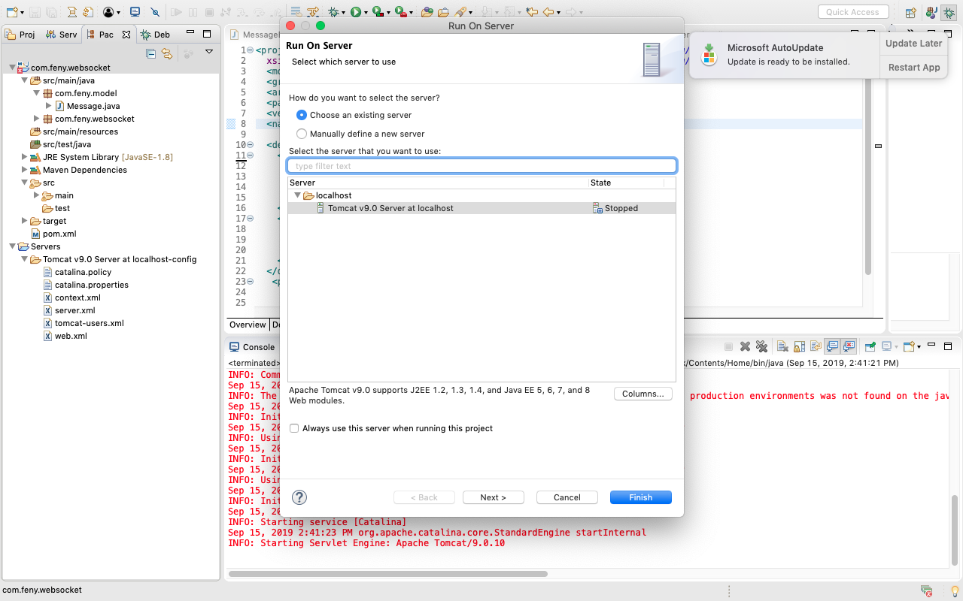

After Tomcat Server already start, then go to web browser like Chrome to open URL :

http://localhost:8080/websocket/

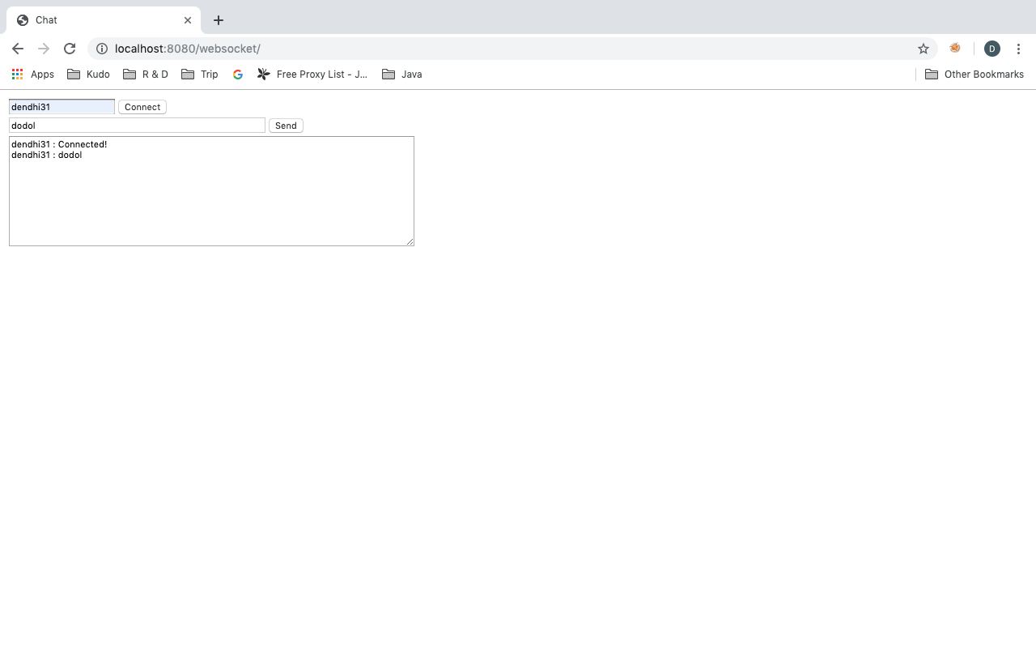

This is how the web socket work in the browser :

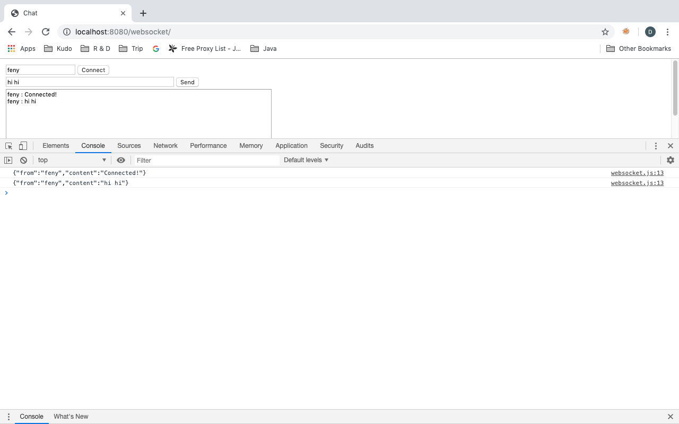

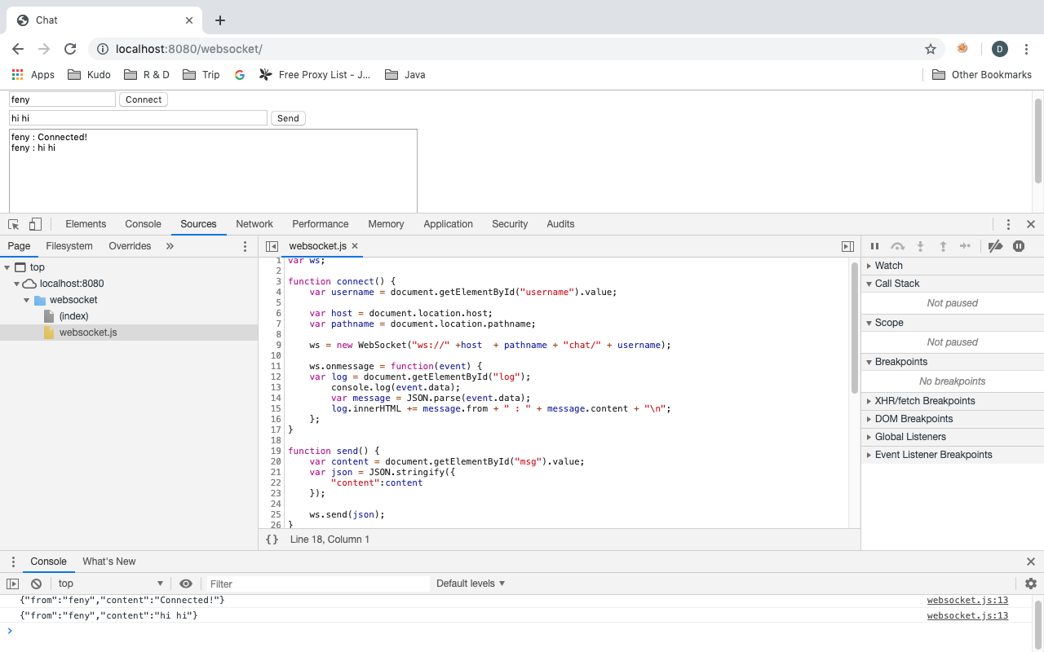

Using URL with parameter {username} with **Request URL:**

ws://localhost:8080/websocket/chat/feny

